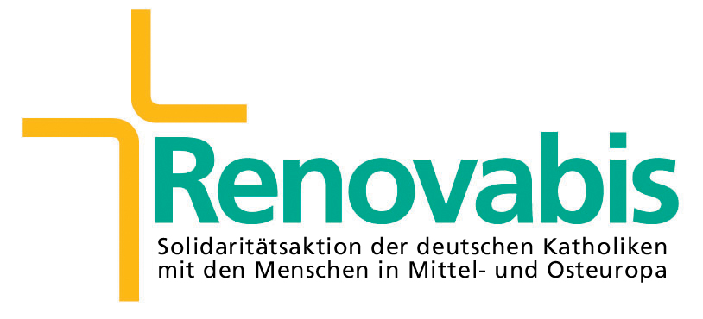
EUROPEAN SOCIETY OF WOMEN IN THEOLOGICAL RESEARCH
EUROPÄISCHE GESELLSCHAFT FÜR THEOLOGISCHE FORSCHUNG VON FRAUEN
ASSOCIATION EUROPÉENNE DES FEMMES POUR LA RECHERCHE THÉOLOGIQUE

Programme of the Regional Conference of ESWTR: 10th – 13th August Prague 2006

„Women Commemorate Women: Spiritual Leaders of Central and Eastern Europe“

Thursday 10th August 2006: arrival day
15:00 – 18:00 | registration of the participants
18:00 | dinner
19:00 | official opening of the conference by the Dean of the Evangelical Theological Faculty of the Charles University | Martin Prudký
19:15 | opening speech by the President of the ESWTR | Adriana Valerio, It
19:30 | opening lecture – Anežka Přemyslovna and Milada Horáková, the struggle for solidarity and pure conscience | Jana Opočenská, Cz
21:00 | opening party

Friday 11th August 2006
7:30 | breakfast
8:00 | morning ritual | Anna Adamičková, Sk
9:00 | morning lecture I – St. Ludmila (English) | Ludmila Profantová, Cz
9:45 | discussion
10:00 | coffee break
10:30 | morning lecture II – Gründerinen – Powerfrauen religiösen Gemeinschaften in Polen (German) | Monika Walus, Pl
11:15 | co-lecture – Gott ist Freude – Geistiges Erbe der Marica Stankovic (German) | Rebeka Anic, Cr
11:45 | discussion
12:30 | lunch
15:00 | mini-lectures (German and English languages groups – no translation)
16:30 | coffee break
17:00 | mini-lectures
19:00 | dinner
20:30 | evening ritual | Kornelia Buday, H

Saturday 12th August 2006
7:30 | breakfast
8:00 | morning ritual | Agnieszka Godfrejow-Tarnogorska, Pl
9:00 | morning lecture III – Women in Days of Apocalypse (English) | Andrea Korečková, Sk
9:45 | discussion
10:00 | coffee break
10:30 | morning lecture IV – Begegnungen in Dieste des Königs – Kristina und die polnische Kultur. Vesuch einer Neubewertung des Beitrags zur Geistesgeschichte in Zentral Europa (German) | Malgorzata Grzywacz, Pl
11:15 | co-lecture – Sister Danuta Gerke – my spiritual leader (English) | Alexandra Blahut-Kowalczyk, Pl
11:45 | discussion
12:30 | lunch
14:00 | panel discussion (English and German) | Ivana Noble, Cz
16:00 | coffee break
16:30 | sightseeing in Prague
20:00 | dinner
21:00 | ritual (Litauen) | Laime Kiskune

Sunday 13th August 2006
8:00 | breakfast
9:00 | FAREWELL RITUAL | Czech women
10:00 | departure

